Social determinants of mental health

People are made vulnerable to mental ill-health by deep-rooted poverty, social inequality, and discrimination. Social arrangements and institutions, such as education, social care, healthcare and work, also have a considerable impact on mental health, for better or for worse. To reduce inequities and promote good mental health, it is vital that action is taken to improve the conditions of everyday life, beginning before birth and progressing into early childhood, older childhood and adolescence, during family-building and working ages, and through to older age.

…social determinants include the conditions in which people are born, live, work, and age, and the health systems they can access, which are in turn shaped by a wider set of forces: economics, social, environmental policies, and politics.

Risk factors for many common mental disorders are heavily associated with social inequalities, whereby the greater the inequality the higher the inequality in risk…the poor and disadvantaged suffer disproportionately from common mental disorders and their adverse consequences but middle classes are also affected. Gender also plays a major role and women tend to have higher levels of common mental disorders compared to men at every level of household income

Importantly, the absence of mental disorder does not necessarily mean the presence of good mental health, which raises significant and important issues in managing mental illness as well as mental well-being.

STATS
The Global Burden of Disease 2010 study estimates that:
- 400 million people across the globe suffer from depression (including dysthymia)
- a further 272 million from anxiety disorders
- 59 million suffer from bipolar disorder
- 24 million from Schizophrenia
- 140 million people are affected by alcohol and drug use disorders
- 80 million children have behavioral disorders (conduct disorder or attention deficit hyperactivity disorder)

Household income is only one of the factors leading to common mental disorders; low educational attainment, material disadvantage, unemployment and for older people social isolation, are other factors, along with gender as noted above.

MENTAL HEALTH ALONG THE LIFE CYCLE
Inevitably those w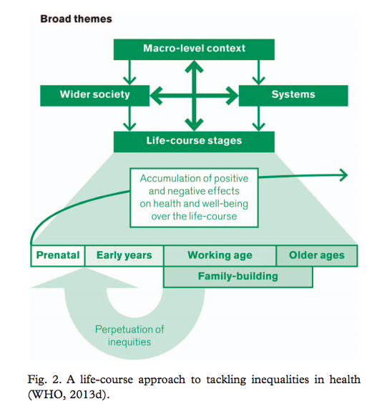ho are lower in the social hierarchy are more likely to experience less favorable economic, social, and environmental conditions throughout life and may have access to fewer buffers and may experience accumulative stress as a result, leading on to mental disorders. Financial debt is also associated with psychiatric disorders and has a gradient effect.

YOUNG PEOPLE
Prevalence of depressed mood or anxiety has been shown to be 2.5 times higher among young people aged 10 to 15 years with low socio-economic status than among youths with high socio-economic status. Household wealth affects children’s emotional and behavioral difficulties even at ages 3 – 5 years

MODEL OF LIFE CYCLE
At every stage in the life course, vulnerability and exposure to harmful processes or stressors can be disruptive, which is why any public mental health intervention needs to take a life course approach.

EMPLOYMENT
Unemployment, irregular and poor-quality employment (such as employment with no or short-term contracts), and jobs with low reward and low control affect mental ill-health. A close association exists between job loss and symptoms of common mental disorders such as depression and anxiety, especially in those individuals who are long-term unemployed. Job security and a sense of control at work are protective factors. Employers who promote greater job control and decreased demand can positively influence mental health by reducing stress, anxiety and depression, and increasing self-esteem, job satisfaction and productivity.

Following the 2008 banking crisis, rates of unemployment rose sharply in the European Union as did rates of suicide. Between 1970 – 2007, in 26 European countries, every 1% increase in unemployment was associated with a 0.79% rise in suicides at ages younger than 65 years. As mentioned above, it is well known that unemployment is associated with an increased risk of depression and job insecurity is associated with sub-optimal mental health.

MICRO FINANCE AS INTERVENTION
It has been argued that every £1 spent on a workplace mental health promotion program would generate £10 in economic returns. Microfinance programs are other potential mechanisms to improve mental health by helping people earn a living and enable communities to work their way out of poverty. These are underutilized resources with the potential to deliver health-related services to large and hard-to-reach populations.

WOMEN AND MATERNAL CARE
Interventions supporting maternal and postnatal mental health benefit parents as well their children and can disrupt the intergenerational transfer of inequities:
• Effective interventions in South Africa have reduced maternal depression and improved child attachment and interaction
• The Mother2Mothers program helped communities develop peer support through education on how to access existing healthcare services. As a result, new mothers experienced more positive changes

OLDER PEOPLE
Depressive mood in older men is related to chronic ill-health, whereas for older women social factors such as levels of isolation, contact with family, and belonging to faith or other community groups play a role. Once again, higher levels of education appear to be a protective factor, particularly for women. Older individuals have a higher risk of developing depression. Indeed, life events related to aging such as bereavement and loss, loss of status, poor physical health and poor social contacts can all contribute to depression.

INTERVENTIONS FOR OLDER PEOPLE
It is apparent that interventions which help prolong levels of activity and reduce social isolation will help reduce depressive symptoms. Reducing social isolation, increasing exercise and physical activity and lifelong learning programs all help, along with a reduction in financial poverty. In cold climates, improving heating in the house help older people and opportunities for older to people to volunteer.

BUILT ENVIRONMENT
The natural and built environment includes both natural and human-made aspects of communities and includes geography and climate, housing quality, water and sanitation systems, air quality, and transportation systems. These factors affect direct and indirect aspects of mental disorders and poor mental health. Overcrowding, for example, can lead to stress and family violence, including child maltreatment, intimate partner violence and sexual violence, and elder abuse.

Living close to natural environments and engaging in outdoor activities such as walking, running, cycling and gardening reduces stress, anxiety and depression.

Connecting with the natural environment benefits mental health. Taking walks in parks improved concentration among children with ADHD, employee mood and performance improved after the introduction of plants into offices.

PRIMARY HEALTHCARE
Primary healthcare should be the bed-rock of healthcare delivery, but different healthcare systems around the globe will provide different types of primary care. Primary healthcare has a significant role to play in promoting good mental health through direct provision and referrals to other more specialized services.

CONCLUSIONS
If healthcare is organized around people ’ s needs and expectations and around the tenets of primary healthcare, it can produce a higher level of health for the same investment.

Examples of community-level interventions in Ghana, Kenya and India.
• Self-help groups in northern Ghana have helped facilitate access to the psychological services offered by the Ghanaian Health Service. These groups in their monthly meetings support each other by sharing tasks such as collecting wood and water, even visiting homes to cook for people and providing financial credit if needed.
• In rural Kenya the BasicNeeds program has also led to significant improvements in mental health, quality of life, social relations, and economic functioning • In India the Comprehensive Rural Health Project is a community-based intervention that integrates mental health into the primary healthcare setting with a strong focus on women, addressing the social and economic determinants of health and educating individuals. Using trained volunteers the intervention works with groups of women from the community to build competence and self-esteem, and to increase perceptions of personal control. These changes in lifestyle and circumstance improved their mental health.

